Full Name:

Nationality:

Date of birth:

Gender:

Address:

Email:

Past or present Institution:

Name of Teacher:

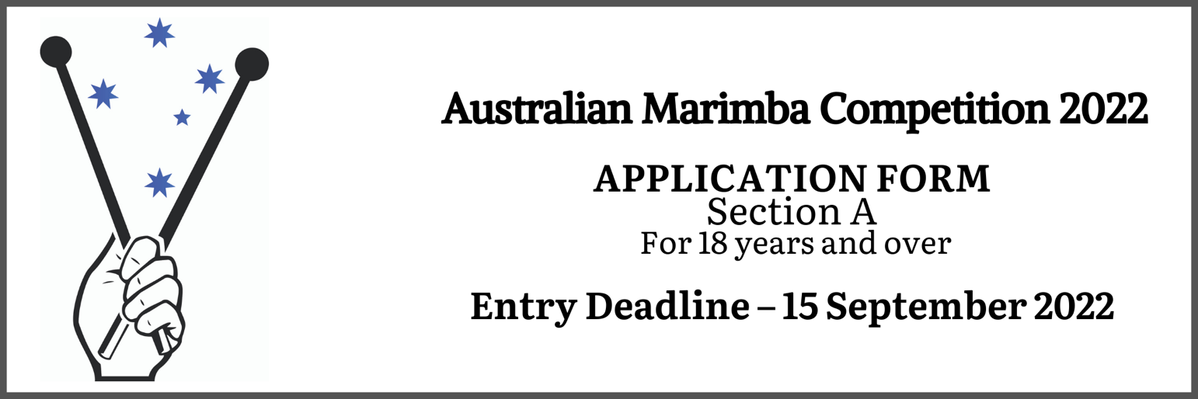
HAVING READ THE RULES, I DECLARE I HAVE ACCEPTED ALL THE REGULATIONS

Signature: |  | Date:

Please pay a Registration Fee for the Section A AUS$165 by following this link:
https://www.trybooking.com/BPPCP

